Week-6: (DAY-26) Hands-On – Keerthivasan R
Problem: 1- SRP – Single Responsibility Principle
Scenario: Student Report Generator
A training institute like Codempower Academy maintains student information and generates performance reports. Currently, one class performs student data storage and report generation, which makes the code difficult to maintain.
Requirements:
1.Create a Student class with properties:
- StudentId
- StudentName
- Marks
2.Create a class responsible for managing student data.
3.Create a separate class responsible for generating reports.
4.The report should display:

Security Requirements (Secure Coding Practices)
Students must implement the following security measures:
Technical Constraints:
- Use C# (.NET Console Application).
- Each class must have only one responsibility.
- Do not mix data storage and report generation logic in the same class.
Expectations:
Students should implement at least three classes:
- Student
- StudentRepository
- ReportGenerator

Program Flow Diagram
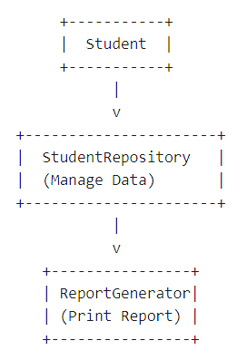
Learning Outcome:
Students will learn:
- Meaning of Single Responsibility Principle
- How to separate responsibilities
- How SRP improves maintainability and testing
CODE:
using System;
using System.Collections.Generic;
using System.Linq;
using System.Text;
using System.Threading.Tasks;

namespace HandsOnDAY26
{
class Student // holds data
{
public int Id { get; set; }
public string Name { get; set; }
public int Marks { get; set; }

public Student(int id, string name, int marks )
{
Id = id;
Name = name;
Marks = marks;
}
}

class StudentRepository // manages data
{
private List<Student> students = new List<Student>();

public void AddStudent(Student student)
{
students.Add(student);
}

public List<Student> GetAllStudents()
{
return students;
}
}

class ReportGenerator // generates report
{
public void GenerateReport(List<Student> students)
{
Console.WriteLine("----- Student Report -----");

foreach (var student in students)
{
string grade = GetGrade(student.Marks);

Console.WriteLine($"ID: {student.Id}");
Console.WriteLine($"Name: {student.Name}");
Console.WriteLine($"Marks: {student.Marks}");
Console.WriteLine($"Grade: {grade}");
Console.WriteLine("-------------------------");
}
}

private string GetGrade(int marks)
{
if (marks >= 90)
{
return "A";
}
else if (marks >= 75)
{
return "B";
}
else if (marks >= 50)
{
return "C";
}
else
{
return "Fail";
}
}
}
internal class Problem_01_SRP // SRP – Single Responsibility Principle
{
static void Main(string[] args)
{
StudentRepository repo = new StudentRepository();

//adding students
repo.AddStudent(new Student(1, "Arun", 92));
repo.AddStudent(new Student(2, "Divya", 76));
repo.AddStudent(new Student(3, "Kiran", 45));

//Geberate Report
ReportGenerator report = new ReportGenerator();
report.GenerateReport(repo.GetAllStudents());
}
}
}

OUTPUT:
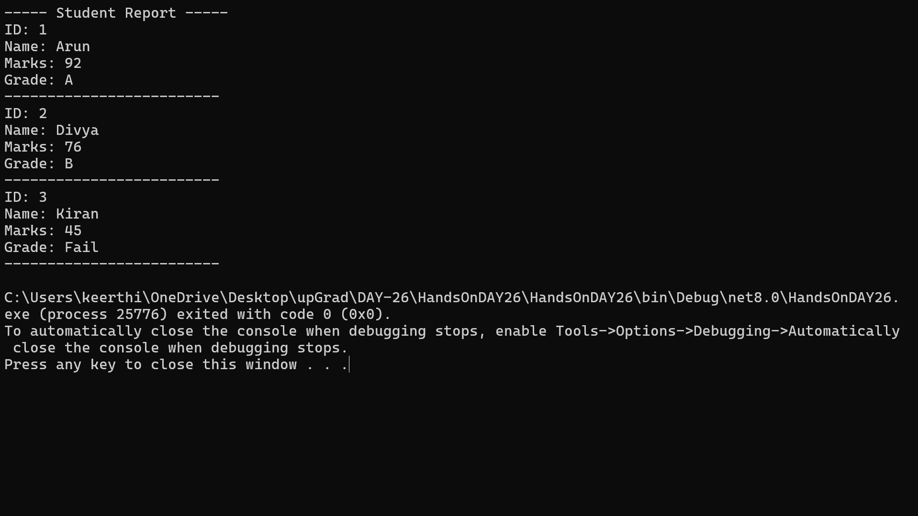

Problem: 2- OCP – Open Closed Principle
Scenario: Discount Calculation System
An e-commerce system calculates discounts for different customer types:
- Regular Customer
- Premium Customer
- VIP Customer
The system should allow adding new discount types without modifying existing code.
Requirements:
- Create an abstract class or interface:
IDiscountStrategy
- Implement discount classes:
- RegularCustomerDiscount
- PremiumCustomerDiscount
- VipCustomerDiscount
- Each class should implement a method:
CalculateDiscount(double amount)
Technical Constraints:
- Use interface or abstract class
- Existing classes should not be modified when adding new discounts
- Follow Open for Extension, Closed for Modification
Expectations:
Students should implement:
- IDiscountStrategy
- 3 Discount Classes
- A class that calculates the final price
Program Flow Diagram:
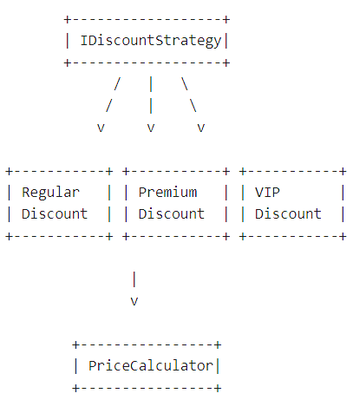
Learning Outcome:
Students will understand:
- Extending functionality without modifying existing code
- Use of interfaces and polymorphism
- Real-world use of Strategy Pattern

CODE:
using System;
using System.Collections.Generic;
namespace HandsOnDAY26
{
// 1. Interface
public interface IDiscountStrategy
{
double CalculateDiscount(double amount);
}
// 2. Discount Classes
public class RegularCustomerDiscount : IDiscountStrategy
{
public double CalculateDiscount(double amount)
{
return amount * 0.05; // 5% discount
}
}
public class PremiumCustomerDiscount : IDiscountStrategy
{
public double CalculateDiscount(double amount)
{
return amount * 0.10; // 10% discount
}
}
public class VipCustomerDiscount : IDiscountStrategy
{
public double CalculateDiscount(double amount)
{
return amount * 0.20; // 20% discount
}
}
// 3. Price Calculator (uses strategy)
public class PriceCalculator
{
private IDiscountStrategy _discountStrategy;

public PriceCalculator(IDiscountStrategy discountStrategy)
{
_discountStrategy = discountStrategy;
}

public double GetFinalPrice(double amount)
{
double discount = _discountStrategy.CalculateDiscount(amount);
return amount - discount;
}
}
// Main Class
internal class Problem_02_OCP {
static void Main(string[] args) {
double amount = 1000;

// Regular Customer
PriceCalculator regular = new PriceCalculator(new RegularCustomerDiscount());
Console.WriteLine("Regular Customer Final Price: " + regular.GetFinalPrice(amount));

// Premium Customer
PriceCalculator premium = new PriceCalculator(new PremiumCustomerDiscount());
Console.WriteLine("Premium Customer Final Price: " + premium.GetFinalPrice(amount));

// VIP Customer
PriceCalculator vip = new PriceCalculator(new VipCustomerDiscount());
Console.WriteLine("VIP Customer Final Price: " + vip.GetFinalPrice(amount));
} }}
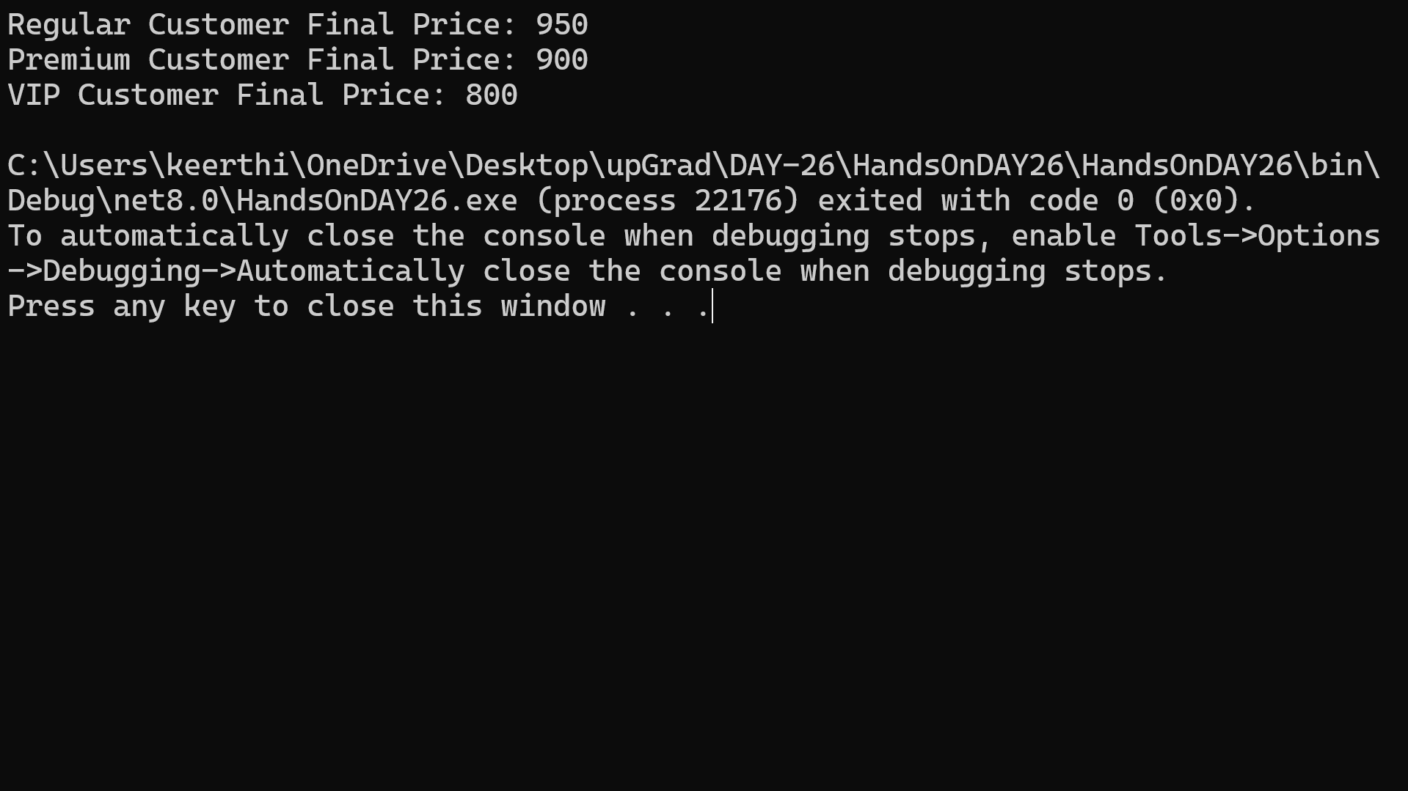
OUTPUT:
Problem 3- LSP – Liskov Substitution Principle
Scenario: Shape Area Calculator
A graphics application calculates the area of different shapes.
Any derived class should be able to replace the base class without breaking functionality.
Requirements:
- Create a base class or interface:
- Shape
- Derived classes:
- Rectangle
- Circle
- Each shape should implement:
- CalculateArea()
- A method should accept Shape object and calculate area.
Technical Constraints:
- Use method overriding
- Derived classes must not break base class behavior
Expectations:
Students should demonstrate that the program works correctly when:
- Rectangle object is used
- Circle object is used

Program Flow Diagram:
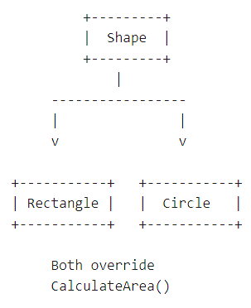
Learning Outcome:
Students will learn:
- Meaning of substitutability
- Importance of correct inheritance
- How polymorphism supports LSP

CODE:
using System;
namespace HandsOnDAY26{
// 1. Base Class
public abstract class Shape {
public abstract double CalculateArea();
}

// 2. Rectangle Class
public class Rectangle : Shape {
public double Length { get; set; }
public double Width { get; set; }

public Rectangle(double length, double width) {
Length = length;
Width = width;
}

public override double CalculateArea() {
return Length * Width;
}
}

// 3. Circle Class
public class Circle : Shape
{
public double Radius { get; set; }

public Circle(double radius)
{
Radius = radius;
}

public override double CalculateArea()
{
return Math.PI * Radius * Radius;
}
}

// Main Class
internal class Problem_03_LSP
{
// Method accepting Shape (LSP in action)
public static void PrintArea(Shape shape)
{
Console.WriteLine("Area: " + shape.CalculateArea());
}

static void Main(string[] args)
{
// Rectangle object
Shape rectangle = new Rectangle(10, 5);
PrintArea(rectangle);

// Circle object
Shape circle = new Circle(7);
PrintArea(circle);
}
}
}
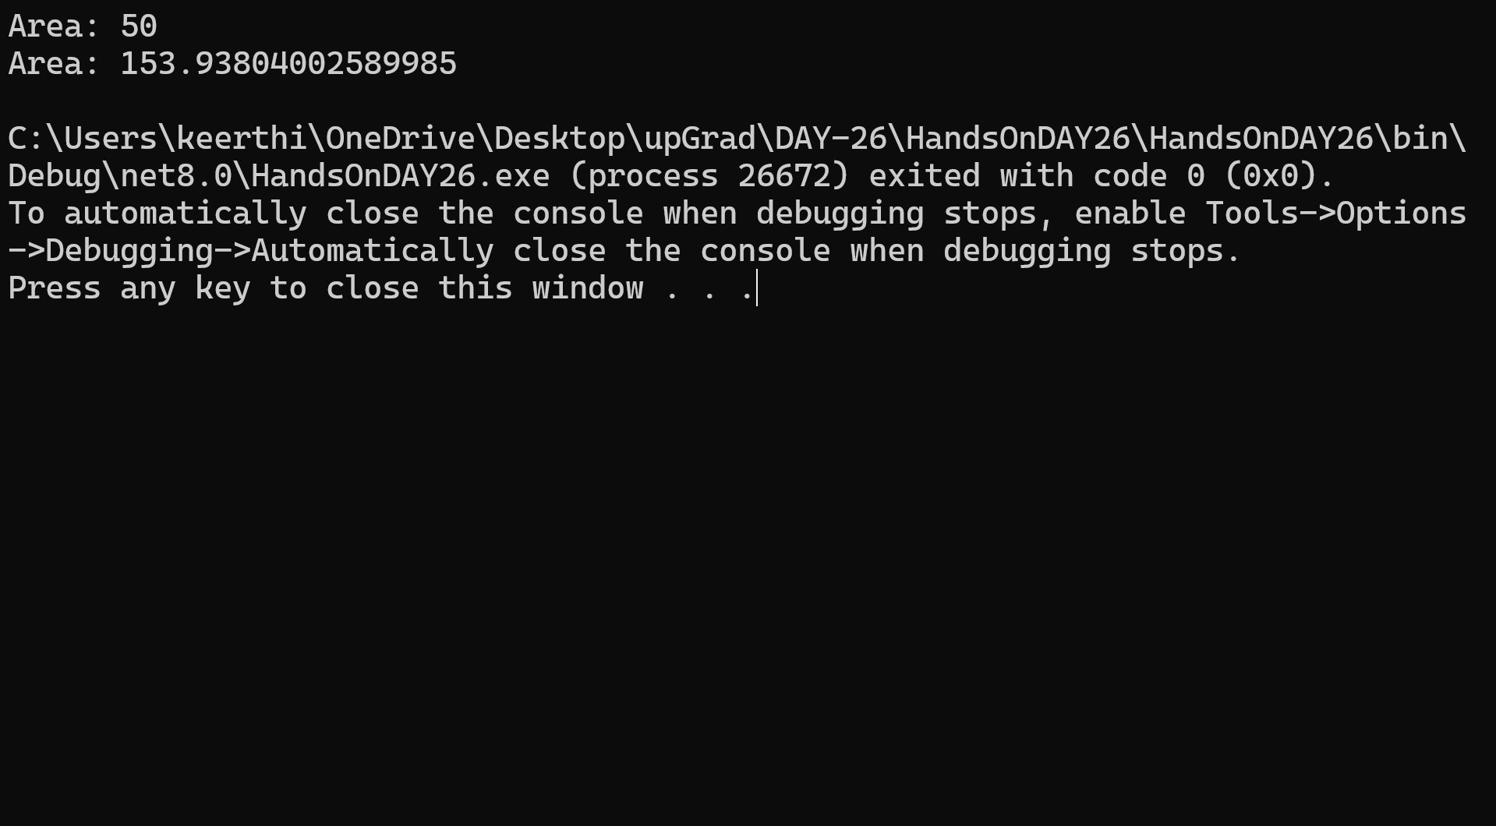
OUTPUT:
Problem 4- ISP – Interface Segregation Principle
Scenario: Office Printer System
An office has different machines:
- Basic Printer (Print only)
- Advanced Printer (Print + Scan + Fax)
If we create a single large interface, basic printers will be forced to implement unnecessary methods.
The task is to split the interface into smaller interfaces.
Requirements:
Create the following interfaces:
- IPrinter
- IScanner
- IFax
Classes:
- BasicPrinter → Print only
- AdvancedPrinter → Print + Scan + Fax
Technical Constraints:
- Follow Interface Segregation Principle
- Classes should not implement unnecessary methods
Expectations:
Students should implement:
Interfaces
- IPrinter
- IScanner
- IFax
Classes
- BasicPrinter
- AdvancedPrinter
Program Flow Diagram:
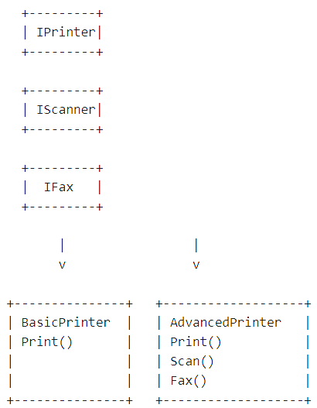

Learning Outcome:
Students will learn:
- Why large interfaces are bad
- How to design small focused interfaces
- Better maintainability and flexibility

CODE:
using System;

namespace HandsOnDAY26
{
// 1. Small Interfaces

public interface IPrinter
{
void Print();
}

public interface IScanner
{
void Scan();
}

public interface IFax
{
void Fax();
}

// 2. Basic Printer (only Print)
public class BasicPrinter : IPrinter
{
public void Print()
{
Console.WriteLine("Basic Printer: Printing document...");
}
}

// 3. Advanced Printer (Print + Scan + Fax)
public class AdvancedPrinter : IPrinter, IScanner, IFax
{
public void Print()
{
Console.WriteLine("Advanced Printer: Printing document...");
}

public void Scan()
{
Console.WriteLine("Advanced Printer: Scanning document...");
}

public void Fax()
{
Console.WriteLine("Advanced Printer: Sending fax...");
}
}

// Main Class
internal class Problem_04_ISP
{
static void Main(string[] args)
{
// Basic Printer
IPrinter basic = new BasicPrinter();
basic.Print();

Console.WriteLine();

// Advanced Printer
AdvancedPrinter advanced = new AdvancedPrinter();
advanced.Print();
advanced.Scan();
advanced.Fax();
}
}
}

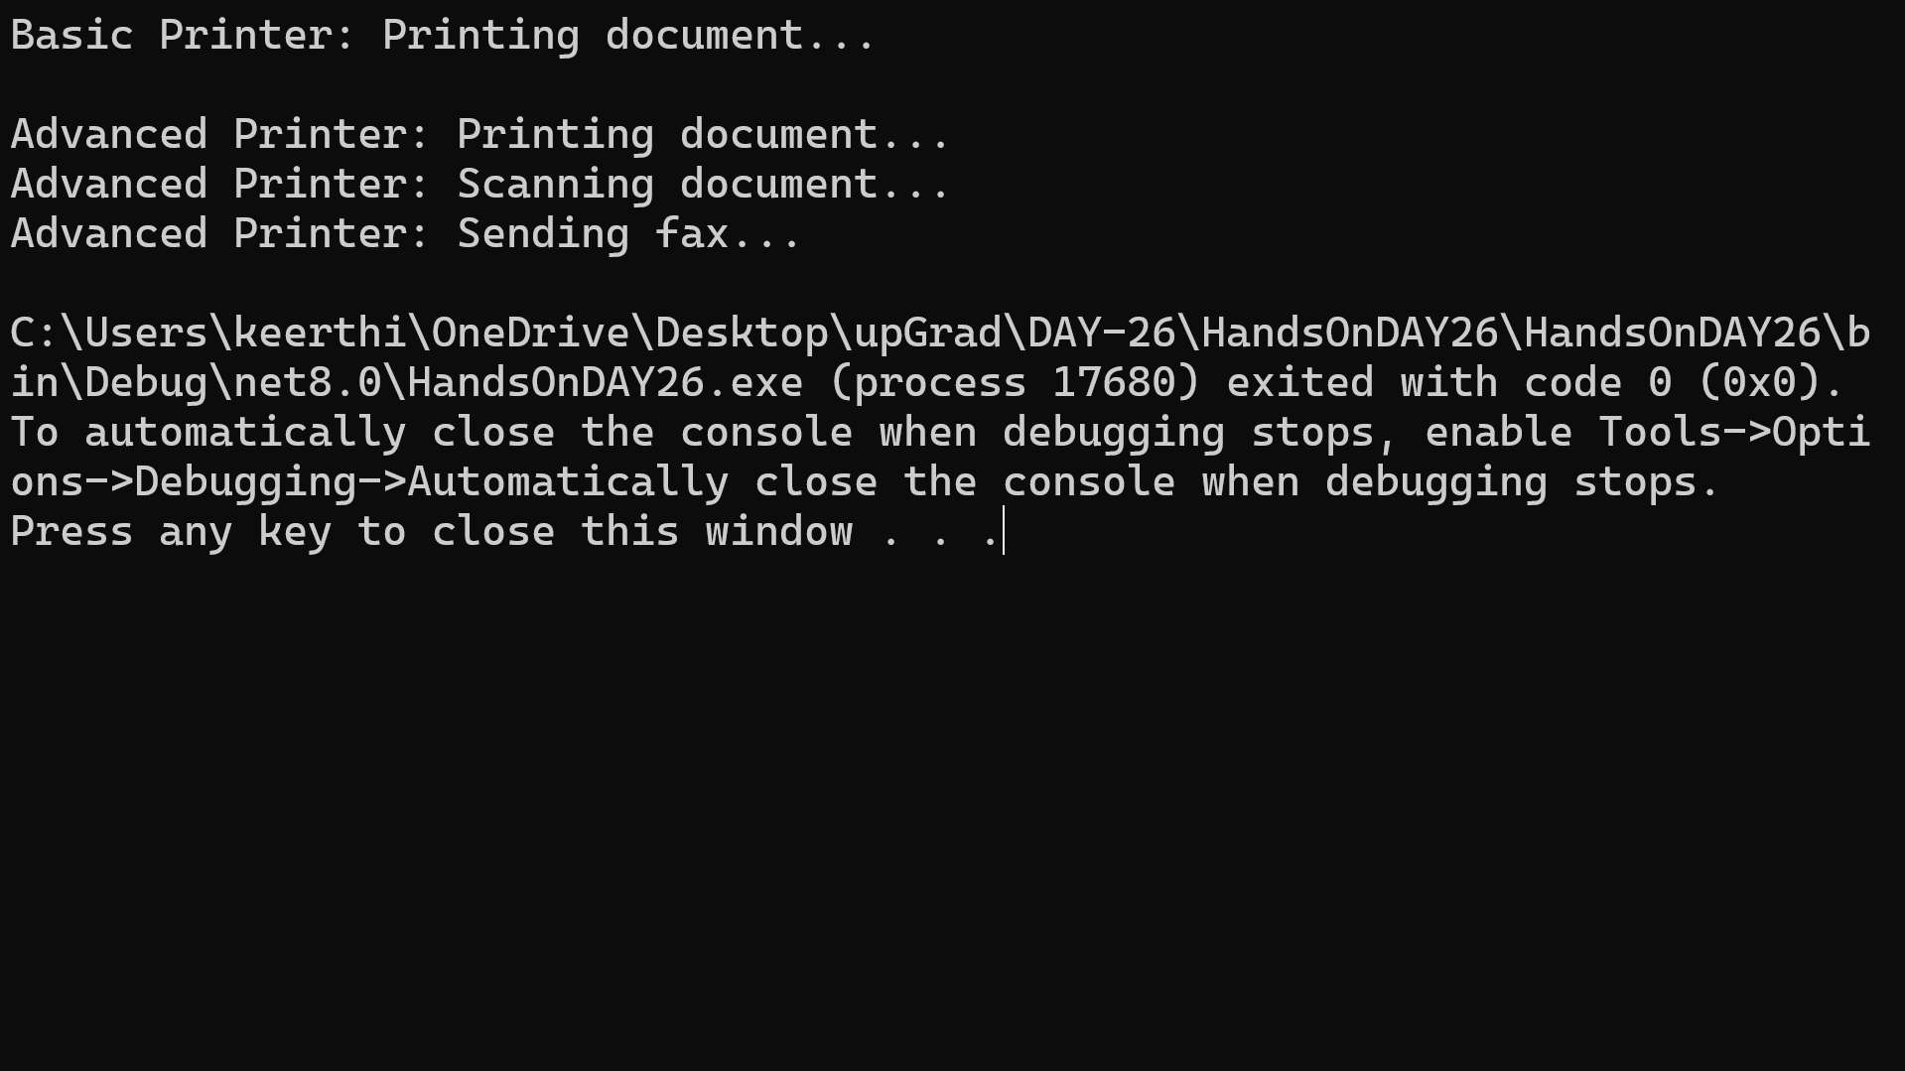
OUTPUT:

Problem 5- Implementing Singleton Pattern
Scenario: Application Configuration Manager
A company is developing a console-based inventory management system.
The application needs to read application settings (e.g., database connection string, app name, version) from a configuration manager.
Since configuration settings should be loaded only once and shared across the entire application, multiple instances of the configuration manager must be prevented.
Therefore, the development team decides to implement the Singleton Design Pattern.
Program Flow Diagram:
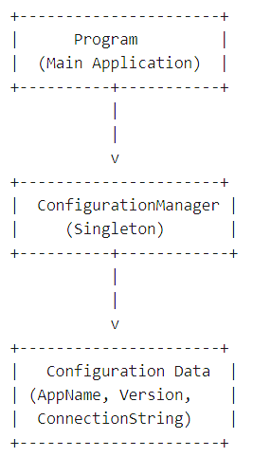
Requirements:
Students must implement:
- A class named ConfigurationManager
- Ensure only one instance of the class can be created.
- Provide a method:
GetInstance()
to retrieve the single object.
- Store configuration values such as:
- ApplicationName
- Version
- DatabaseConnectionString
- Demonstrate that multiple calls to GetInstance() return the same instance.
Technical Constraints:
- Use private constructor.
- Use static instance variable.
- Use thread-safe implementation (basic level optional).
- Console application using C# (.NET).
Expectations:
Students should:
- Prevent object creation using new.
- Access instance using:
ConfigurationManager.GetInstance()
- Print configuration details from multiple method calls.
Learning Outcome:
After completing this problem, learners will understand:
- Why Singleton is used
- How to restrict object creation
- Global shared objects
- Basic design pattern implementation in C#

CODE:
using System;
namespace HandsOnDAY26{
// 1. Singleton Class
public class ConfigurationManager {
// Static instance (only one object)
private static ConfigurationManager instance;
// Lock object for thread safety (optional basic level)
private static readonly object lockObj = new object();
// Properties
public string ApplicationName { get; set; }
public string Version { get; set; }
public string DatabaseConnectionString { get; set; }
// Private constructor (prevents new keyword)
private ConfigurationManager() {
// Default values
ApplicationName = "Inventory System";
Version = "1.0.0";
DatabaseConnectionString = "Server=localhost;Database=InventoryDB;"; }

// GetInstance method
public static ConfigurationManager GetInstance() {
if (instance == null) {
lock (lockObj) {
if (instance == null) {
instance = new ConfigurationManager();
}
}
}
return instance;
}
}
// Main Class
internal class Problem_05_Singleton_Implementation {
static void Main(string[] args) {
// First call
ConfigurationManager config1 = ConfigurationManager.GetInstance();
// Second call
ConfigurationManager config2 = ConfigurationManager.GetInstance();
// Print details from both instances
Console.WriteLine("First Instance:");
Console.WriteLine(config1.ApplicationName);
Console.WriteLine(config1.Version);
Console.WriteLine(config1.DatabaseConnectionString);
Console.WriteLine();
Console.WriteLine("Second Instance:");
Console.WriteLine(config2.ApplicationName);
Console.WriteLine(config2.Version);
Console.WriteLine(config2.DatabaseConnectionString);
Console.WriteLine();
// Check if both instances are same
Console.WriteLine("Are both instances same? " + (config1 == config2)); }
}
}
OUTPUT:
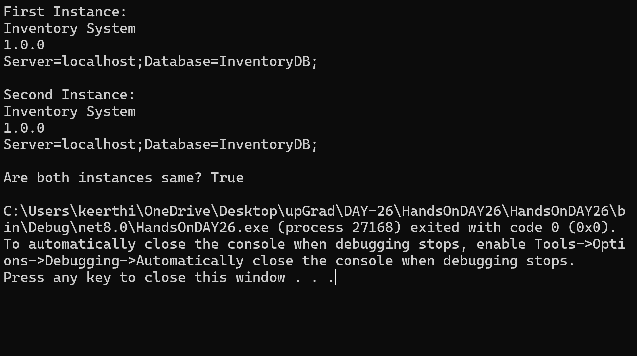

Problem 6- Implementing Factory Pattern
Scenario: Notification Service
A company application sends notifications to users using different communication channels:
- Email
- SMS
- Push Notification
The application should not directly create objects using new.
Instead, a Factory class should determine which notification service to create.
Program Flow:

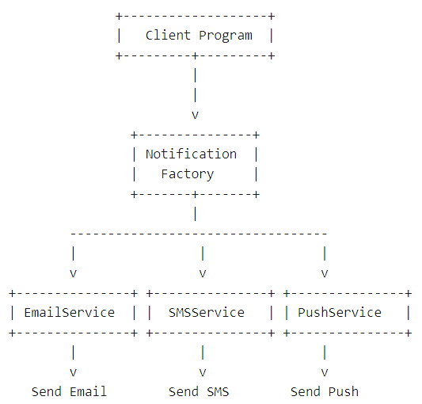
Requirements:
Students must implement:
- Interface
INotification
- Method:
Send(string message)
Classes
- EmailNotification
- SMSNotification
- PushNotification
Each class should implement INotification.
Factory Class
NotificationFactory
Method:
CreateNotification(string type)
Example:
CreateNotification("email")
CreateNotification("sms")
CreateNotification("push")
Technical Constraints
- Use interface-based design.
- Client should not instantiate concrete classes directly.
- Use Factory Pattern to create objects.
- Language: C# Console Application.

Expectations:
Students should demonstrate:
NotificationFactory factory = new NotificationFactory();
var notification = factory.CreateNotification("email");
notification.Send("Welcome to our service!");
Learning Outcome:
Students will learn:
- Decoupling object creation from usage
- Interface-based programming
- Open/Closed Principle basics
- Real-world object creation management

CODE:
using System;

namespace HandsOnDAY26
{
// 1. Interface
public interface INotification
{
void Send(string message);
}

// 2. Concrete Classes

public class EmailNotification : INotification
{
public void Send(string message)
{
Console.WriteLine("Email Sent: " + message);
}
}

public class SMSNotification : INotification
{
public void Send(string message)
{
Console.WriteLine("SMS Sent: " + message);
}
}

public class PushNotification : INotification
{
public void Send(string message)
{
Console.WriteLine("Push Notification Sent: " + message);
}
}

// 3. Factory Class
public class NotificationFactory
{
public INotification CreateNotification(string type)
{
switch (type.ToLower())
{
case "email":
return new EmailNotification();

case "sms":
return new SMSNotification();

case "push":
return new PushNotification();

default:
throw new ArgumentException("Invalid notification type");
}
}
}

// Main Class
internal class Problem_06_Implementing_Factory_Pattern
{
static void Main(string[] args)
{
NotificationFactory factory = new NotificationFactory();

var email = factory.CreateNotification("email");
email.Send("Welcome to our service!");

var sms = factory.CreateNotification("sms");
sms.Send("Your OTP is 123456");

var push = factory.CreateNotification("push");
push.Send("You have a new alert!");
}
}
}
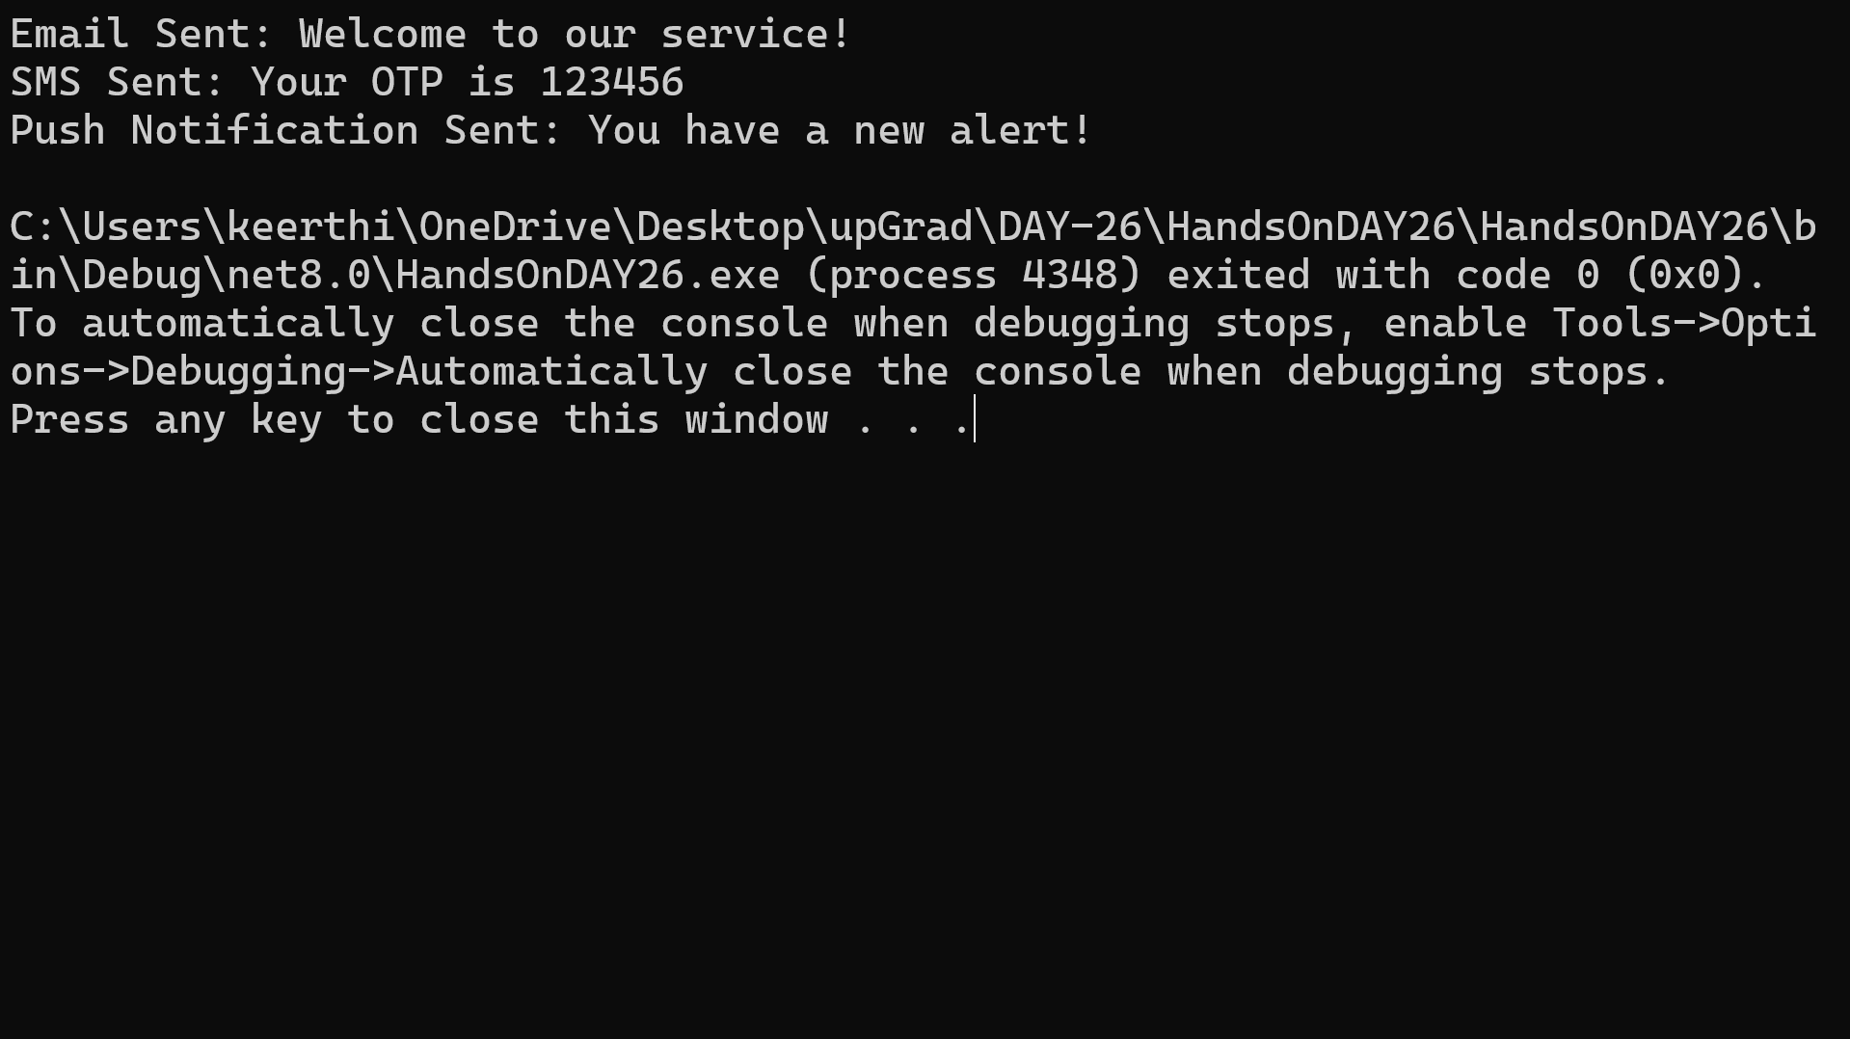
OUTPUT:

Problem 7- Implementing Repository Pattern
Scenario: Student Data Management System
A training institute needs a system to manage student information.
Instead of directly writing database access code in the main program, the development team decides to use the Repository Pattern.
The repository will act as a data access layer between the application and the data source.
For simplicity, student data will be stored in a List collection.
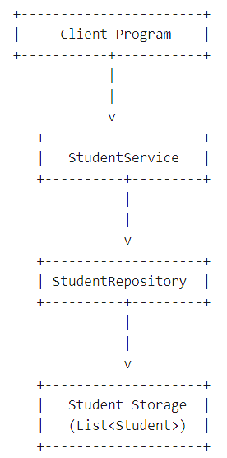
Requirements:
Create the following components:
Entity Class:
Student
Properties:
StudentId
StudentName
Course
Repository Interface:
IStudentRepository
Methods:
AddStudent(Student student)
GetAllStudents()
GetStudentById(int id)
DeleteStudent(int id)
Repository Implementation:
StudentRepository
Store data using:
List<Student>
Main Program
Demonstrate:
- Adding students
- Viewing students
- Finding student by ID
- Deleting student
Expectations:
Students should implement separation between:
Business Logic
↓
Repository Layer
↓
Data Storage

Learning Outcome:
Students will understand:
- Separation of concerns
- Data access abstraction
- Clean architecture basics
- How repositories simplify data operations

CODE:
using System;
using System.Collections.Generic;
using System.Linq;

namespace HandsOnDAY26
{
// Entity Class
public class RepoStudent
{
public int StudentId { get; set; }
public string StudentName { get; set; }
public string Course { get; set; }

public RepoStudent(int id, string name, string course)
{
StudentId = id;
StudentName = name;
Course = course;
}
}

// Repository Interface
public interface IRepoStudentRepository
{
void AddStudent(RepoStudent student);
List<RepoStudent> GetAllStudents();
RepoStudent GetStudentById(int id);
void DeleteStudent(int id);
}

// Repository Implementation
public class RepoStudentRepository : IRepoStudentRepository
{
private List<RepoStudent> students = new List<RepoStudent>();

public void AddStudent(RepoStudent student)
{
students.Add(student);
}

public List<RepoStudent> GetAllStudents()
{
return students;
}

public RepoStudent GetStudentById(int id)
{
return students.FirstOrDefault(s => s.StudentId == id);
}

public void DeleteStudent(int id)
{
var student = GetStudentById(id);
if (student != null)
{
students.Remove(student);
}
}
}

// Main Class
internal class Implementing_Repository_Pattern
{
static void Main(string[] args)
{
// ✅ Correct: Use implementation class
IRepoStudentRepository repo = new RepoStudentRepository();

// Adding Students
repo.AddStudent(new RepoStudent(1, "Arun", "Java"));
repo.AddStudent(new RepoStudent(2, "Divya", "Python"));
repo.AddStudent(new RepoStudent(3, "Kiran", "C#"));

// View All Students
Console.WriteLine("All Students:");
foreach (var s in repo.GetAllStudents())
{
Console.WriteLine($"ID: {s.StudentId}, Name: {s.StudentName}, Course: {s.Course}");
}

Console.WriteLine();

// Find Student by ID
Console.WriteLine("Search Student with ID 2:");
var student = repo.GetStudentById(2);
if (student != null)
{
Console.WriteLine($"Found: {student.StudentName}, Course: {student.Course}");
}
else
{
Console.WriteLine("Student not found");
}

Console.WriteLine();

// Delete Student
Console.WriteLine("Deleting Student with ID 1...");
repo.DeleteStudent(1);

Console.WriteLine("Students After Deletion:");
foreach (var s in repo.GetAllStudents())
{
Console.WriteLine($"ID: {s.StudentId}, Name: {s.StudentName}, Course: {s.Course}");
}
}
}
}
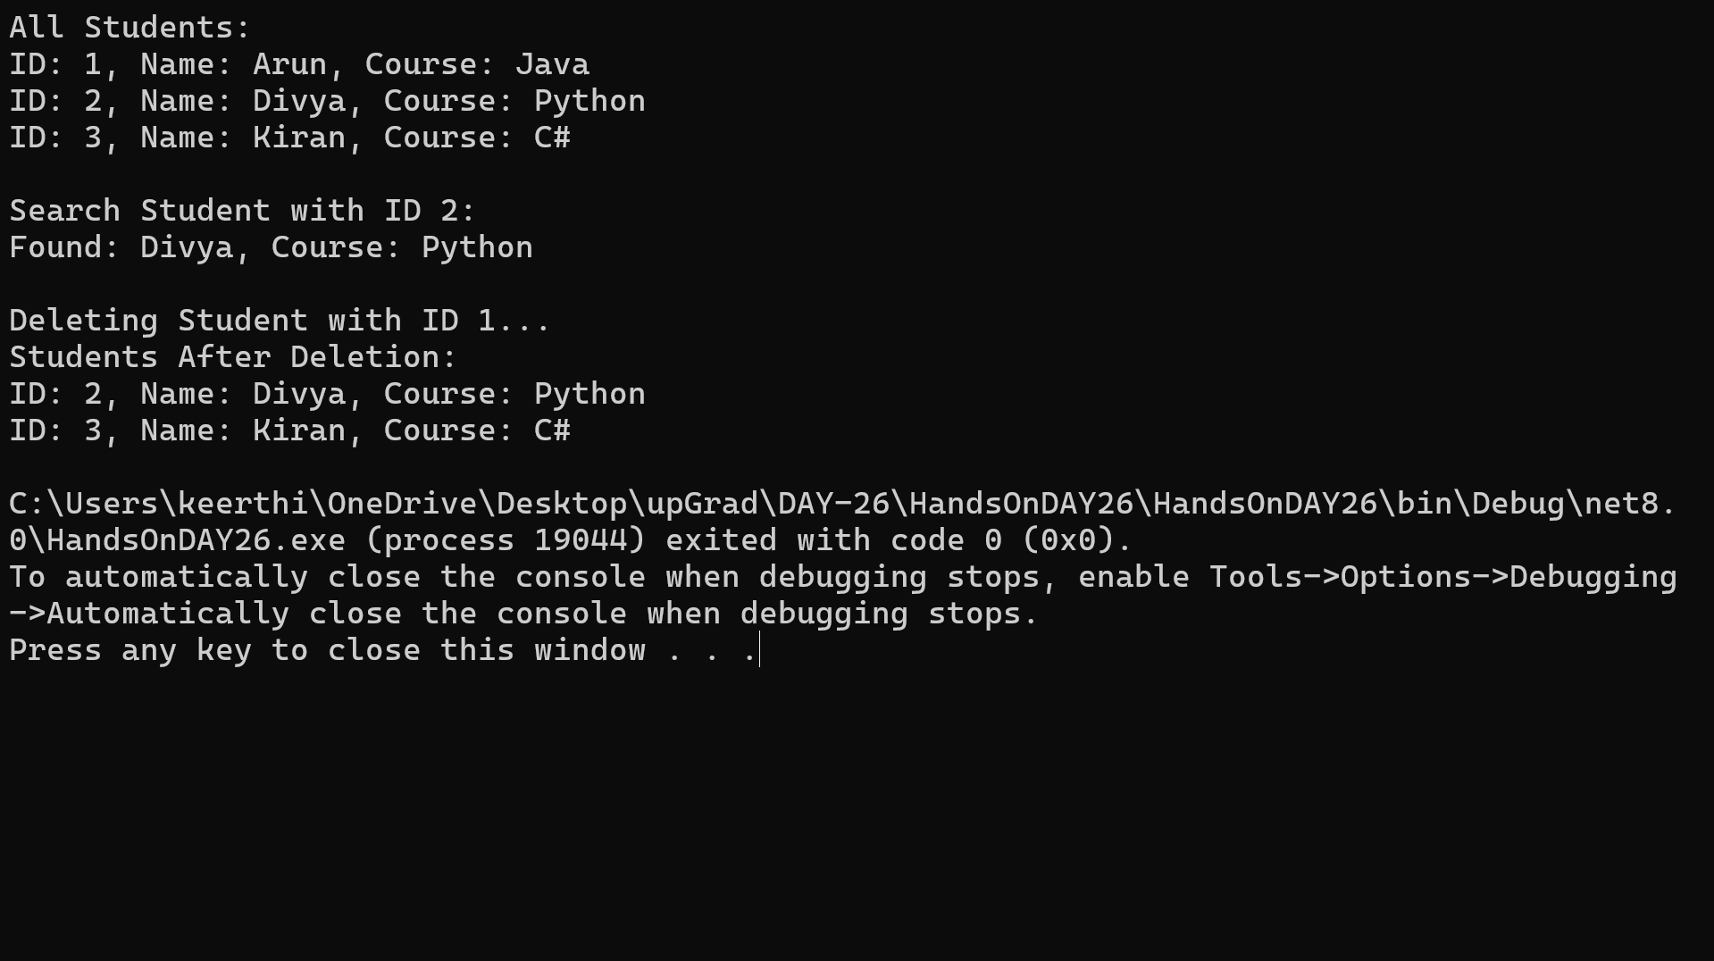
OUTPUT:

